Name ______________________  Class_________________ | Year 9  Mini Test  Probability & Coordinate Geometry | 

- What is the theoretical probability of rolling a 2 on a die? (1)

- I tossed a coin 10 times to get the results;

H,T,H,H,T,H,T,H,H,H

Therefore, the P (H) = 7/10 is an example of theoretical/experimental probability. Cross out the word that makes the statement incorrect. (1)

- Complete the following table for tossing two coins. (3)

 |  | Coin 2
 |  | H | T
Coin 1 | H
 | T

- What is the probability of getting 2 tails?

- Scrabble tiles have been placed in a hat. The only tiles in the hat make the word MATHEMATICS. A tile is selected randomly.
Determine the probability it will be; (5)

- a M

- a vowel

- not a vowel

- an M or a C

- a letter from the word SCIENCE
- There are three marbles in a bag; 1 red, 1 blue and 1 yellow marble. We pull out one marble and place it on the bench. We then pull out a second marble and place that on the bench too. Draw a tree diagram to represent all of the possible combinations of marbles on the bench. List the outcomes on the side of the tree diagram. (4)

- Complete the two way table below for students in Mr Torana’s class about if they like apples and bananas. (6)

 | Like bananas | Dislike bananas | Total
Like apples | 7 |  | 23
Dislike apples |  | 4
Total |  | 20 | 32

Determine the probability that the students

- like apples and bananas.

- like apples or bananas.

- don’t like apples

- In a class of 33 students, 23 have an iphone and 9 have a samsung. Four had both an iphone and a Samsung. Five students do not have phones.

- Represent this using a Venn diagram. (4)

- What is the probability that a student has an iphone and a Samsung? (1)

- What is the probability that a student has an iphone? (1)

- For the diagram below determine; (6)
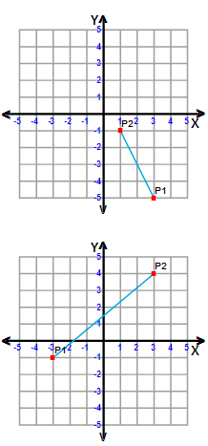

a)The distance between the two points.

b)The gradient of the line.

c)The midpoint of P1 and P2.

- Determine the midpoint of the points (3, 2) and (-4, 3). (3)

